PROG2002 – Web Development II
Assignment 2: Use Case (A Dynamic Website)
Student ID: Last Name: First Name:
Title of the project:

Sydney Community Giving charity events website

Introduction/Motivation
Sydney Community Giving organises charity events across Sydney to raise money for food relief, youth mentoring, housing support and creative learning. The website gives people one calendar where they can check what is coming up, how much entry costs and what each event supports. Those details matter before someone travels to a venue or invites friends.
The calendar includes a harbour run, a free makers market at Carriageworks, music in Newtown and fundraising dinners. This range lets visitors consider several ways to take part while the site presents free and paid entry in a consistent way.

Problem Statement
A useful event list changes with time. Once a run ends, it should leave the public calendar. A suspended event must disappear even if its date is still in the future. Maintaining separate event details in static HTML would make those rules harder to apply consistently.
Visitors arrive with different constraints. Someone free on a particular day may search by date, while a person near Newtown may combine suburb and category. After finding a listing, they need the schedule, venue, cause, ticket information and fundraising progress. The website must support those tasks without suggesting that online registration or payment already works.

Solution
MySQL stores organisations, categories and events. A Node.js/Express server serves the pages and read-only API. The event_db.js module opens a connection pool with database credentials from environment variables.
The home.js script requests /api/events and builds the featured event and remaining cards from the JSON response. On the search page, search.js first loads /api/categories. It then sends the chosen date, location and category as query parameters to /api/events. The detail page reads the ID from event.html?id=... and requests /api/events/:id. Serving the pages and API from one Express origin keeps those requests straightforward.
The shared requestJSON function uses fetch, checks the HTTP status and reports network or malformed-response errors. Event cards are built with DOM methods and textContent. On the search page, a request counter stops an older response from replacing newer results if a visitor searches twice in quick succession. The detail page displays a registration form, but pressing Register only shows "This feature is currently under construction." No name, email or ticket choice is sent to the server.

Web UX
Home, Events and About appear in every page’s navigation. The home page introduces the organisation, gives the next event a larger card and places other events below it. Cards show date, suburb, category, price and a short description, and link to the detail page. About explains the causes for visitors who want more context.
The search form has a native date input, a venue or suburb field and an API-fed category selector. Each filter works alone or with the others. Clear filters resets all fields and reloads the public list. The result count confirms a search; separate messages cover no matches, a failed request and unavailable categories.
On the detail page, schedule, venue, ticket price and organiser sit beside description and purpose. Free events say Free. Raised and target amounts appear as numbers, a bar and a text percentage. Columns stack on phones; labels, a skip link, visible focus and live status messages support keyboard use.

Data Schema
The database has organisations, categories and events. Each table has an integer primary key. Events has foreign keys to the other two, forming two one-to-many relationships. Category names are unique.
An event stores its name, short and full descriptions, purpose, local date and start and end times, venue, suburb, city, image filename, ticket price, fundraising goal, amount raised and suspension flag. Ticket and fundraising values use DECIMAL columns so they are stored as monetary amounts. The image filename selects a local asset without duplicating the image in the database.
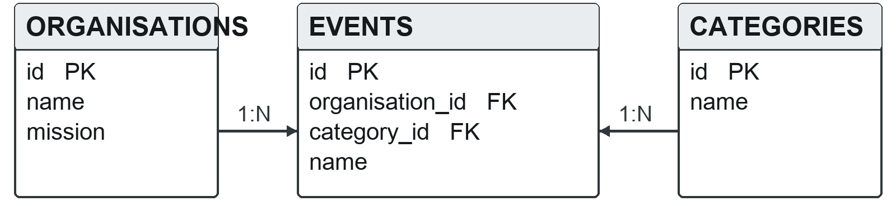
Figure 1. Relationships between organisations, events and categories
The SQL file inserts one organisation, four categories and ten events. Eight are public and scheduled after import, one has already finished, and one is suspended. Their dates are calculated from the day the SQL is imported, so the public list can be demonstrated after a fresh setup. The past and suspended records also check the visibility rules.
Database checks require an end time after the start time, a non-negative ticket price, a positive goal and a non-negative amount raised. Indexes support the visibility and date check and the category filter. The server also formats the current time for Australia/Sydney before deciding which events belong in public listings.
Keeping organisations and categories in separate tables avoids copying their names into every event. The API joins those tables to events, so cards and detail pages receive the organiser and category labels from one source.

API design
The API exposes events and categories as resources. All three routes retrieve data, so each uses GET and has no request body. Search terms are optional query parameters; the detail route takes the event ID in its path. Express returns JSON rather than HTML so the page scripts can decide how to display each result.
Route | Request | Successful response
GET /api/events | Optional date, location and categoryId query values; no body. | JSON summaries of unfinished, non-suspended events in date order.
GET /api/categories | No parameters or body. | JSON array of category IDs and names, ordered by name.
GET /api/events/:id | Positive event ID in the path; no body. | One JSON event with its full description, purpose, price, goal and raised amount.
For example, GET /api/events?location=Newtown&categoryId=3 requests Arts & Music events in Newtown. It has no request body. While Enmore Benefit Night remains upcoming, the JSON array includes its ID, name, date, venue, ticket price and category, among other summary fields. The server searches venue, suburb and city for the location term.
The event list excludes suspended records and events whose end time has passed in Sydney. Its date, location and category conditions are combined with AND, so adding a filter narrows the results. The detail route excludes suspended events and adds the full description, purpose and fundraising figures to the summary fields. A finished but unsuspended event can still be retrieved directly by ID, though it no longer appears in the public list.
The server rejects invalid YYYY-MM-DD dates, locations over 100 characters and non-positive IDs with HTTP 400. Query values use SQL placeholders; LIKE wildcard characters are escaped in location searches. Unknown or suspended details return 404, and database failures return 500. POST, PUT and DELETE are outside this version because registration and administration do not write data. The smoke test checks filters, details and error responses.

